After I have written a HTML file, as a developer, I need to run my own web server to display my content. A web server is just a program sitting there, waiting and waiting for someone to send a request from a browser, so it can send a respond back.

Rendering basically means interpreting.

***“The language that Web pages are written in is HTML”***

**HTML** (Hyper Text Markup Language)

- It lays out the structure of the web page, it’s used to add data such as text and images to the

web page

**CSS** (Cascading Style Sheets)

- It’s used to style the HTML content (font sizes, colors, spacing, positioning, borders,

background)

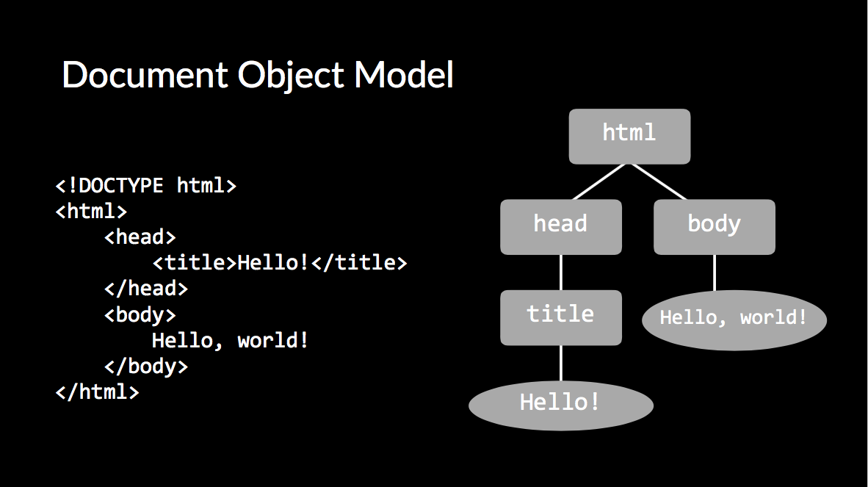

**JavaScript**

- JS is usually used in client-side development (front-end dev), but Node.js was then created to support server-side development (back-end dev).

It makes web pages dynamic by adding new objects to the DOM tree dynamically. It lets you control the user’s browser even after they loaded your web page for the first time.

*JavaScript is made for the web, interpreted, and high-level. Its code typically only runs in browsers.* It’s so popular that most web browsers have a built-in engine just to handle it.

C++ is often used to write compilers or interpreters for other languages; including many of the engines that interpret JavaScript.

Lecture1--HTML, CSS

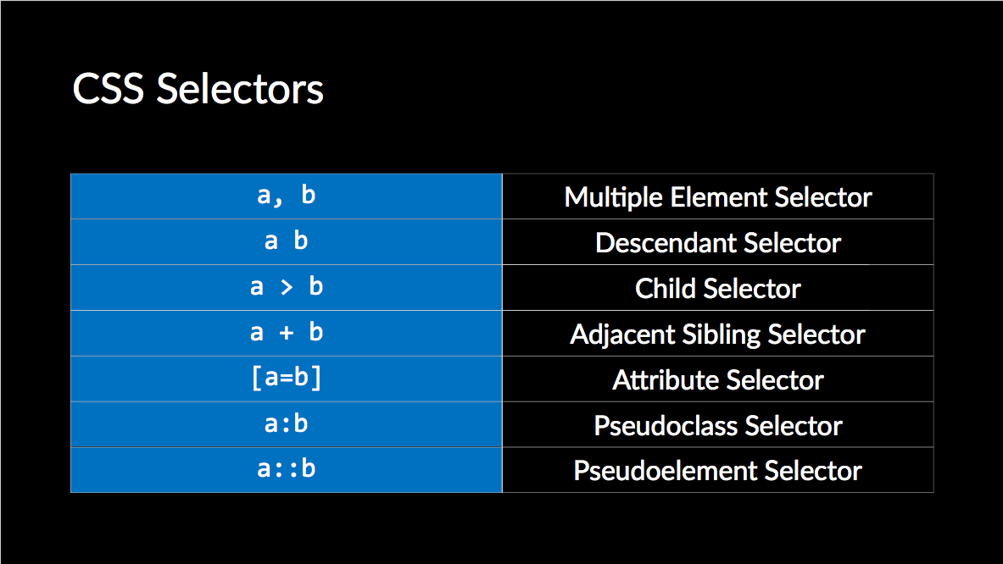

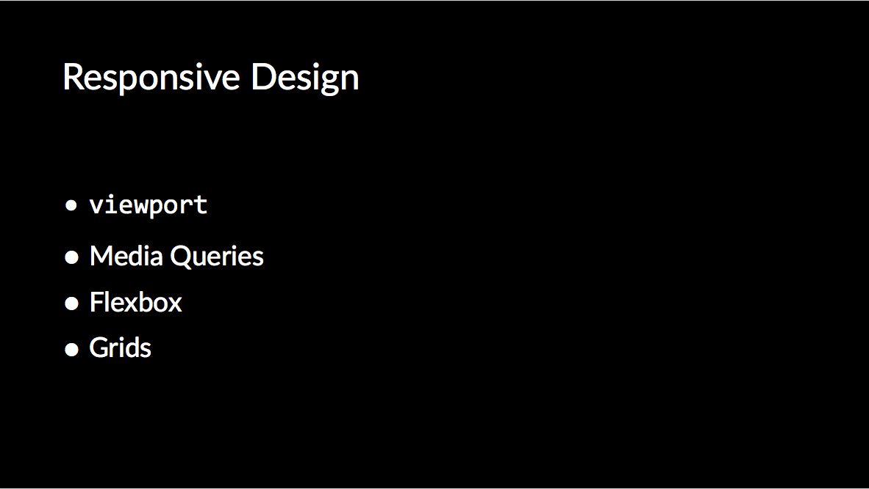

These can all be taken care of by Bootstrap.

**Lecture3--SQL**

Databases can be used to make it easier for web applications to store, organize, and retrieve data. Particularly useful are relational databases; in other words, tables.

**SQL** (Structured Query Language) is a language designed to interact with these relational databases. In this class, PostgreSQL will be used, but there are many other versions with slightly different features.

psql <database name> 🡪 to enter the psql shell (to connect to databases to execute SQL

statements. exit by typing ctrl + d)

\list 🡪 To list all databases

create database <database name>; 🡪 create a new database

drop database <database name>; 🡪 remove a database

\connect <database name>; 🡪 connect from current database to another database